## Create First Web Page With Bootstrap 4

**1. Add the HTML5 doctype**

Bootstrap 4 uses HTML elements and CSS properties that require the HTML5 doctype.

Always include the HTML5 doctype at the beginning of the page, along with the lang attribute and the correct character set:

<!DOCTYPE html>  
<html lang="en">  
  <head>  
    <meta charset="utf-8">   
  </head>  
</html>

**2. Bootstrap 4 is mobile-first**

Bootstrap 4 is designed to be responsive to mobile devices. Mobile-first styles are part of the core framework.

To ensure proper rendering and touch zooming, add the following <meta> tag inside the <head> element:

<meta name="viewport" content="width=device-width, initial-scale=1">

The width=device-width part sets the width of the page to follow the screen-width of the device (which will vary depending on the device).

The initial-scale=1 part sets the initial zoom level when the page is first loaded by the browser.

**3. Containers**

Bootstrap 4 also requires a containing element to wrap site contents.

There are two container classes to choose from:

1. The .container class provides a responsive **fixed width container**
2. The .container-fluid class provides a **full width container**, spanning the entire width of the viewport

.container

.container-fluid

Bootstrap 4 Grid System

Bootstrap's grid system is built with flexbox and allows up to 12 columns across the page.

If you do not want to use all 12 columns individually, you can group the columns together to create wider columns:

|  |  |  |  |  |  |  |  |  |  |  |  |
| --- | --- | --- | --- | --- | --- | --- | --- | --- | --- | --- | --- |
| span 1 | span 1 | span 1 | span 1 | span 1 | span 1 | span 1 | span 1 | span 1 | span 1 | span 1 | span 1 |
| span 4 | | | | span 4 | | | | span 4 | | | |
| span 4 | | | | span 8 | | | | | | | |
| span 6 | | | | | | span 6 | | | | | |
| span 12 | | | | | | | | | | | |

The grid system is responsive, and the columns will re-arrange automatically depending on the screen size.

Make sure that the sum adds up to 12 or fewer (it is not required that you use all 12 available columns).

Grid Classes

The Bootstrap 4 grid system has five classes:

* .col- (extra small devices - screen width less than 576px)
* .col-sm- (small devices - screen width equal to or greater than 576px)
* .col-md- (medium devices - screen width equal to or greater than 768px)
* .col-lg- (large devices - screen width equal to or greater than 992px)
* .col-xl- (xlarge devices - screen width equal to or greater than 1200px)

The classes above can be combined to create more dynamic and flexible layouts.

**Tip:** Each class scales up, so if you wish to set the same widths for sm and md, you only need to specify sm.

First example: create a row (<div class="row">). Then, add the desired number of columns (tags with appropriate.col-*-* classes). The first star (*) represents the responsiveness: sm, md, lg or xl, while the second star represents a number, which should add up to 12 for each row.

Second example: instead of adding a number to each col, let bootstrap handle the layout, to create equal width columns: two "col" elements = 50% width to each col. three cols = 33.33% width to each col. four cols = 25% width, etc. You can also use .col-sm|md|lg|xl to make the columns responsive.

<div class="container-fluid">

<h1>Two Unequal Responsive Columns</h1>

<p>Resize the browser window to see the effect.</p>

<p>The columns will automatically stack on top of each other when the screen is less than 576px wide.</p>

<div class="row">

<div class="col-sm-4" style="background-color:lavender;">.col-sm-4</div>

<div class="col-sm-8" style="background-color:lavenderblush;">.col-sm-8</div>

</div>

</div>

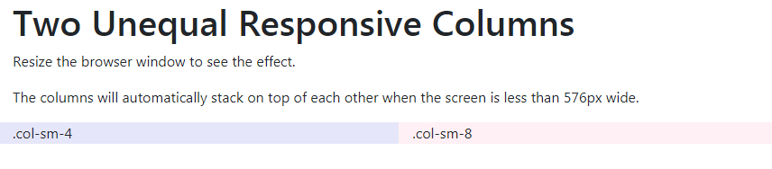

<div class="container-fluid">

<h1>Three equal width columns</h1>

<p>Note: Try to add a new div with class="col" inside the row class - this will create four equal-width columns.</p>

<div class="row">

<div class="col" style="background-color:lavender;">.col</div>

<div class="col" style="background-color:orange;">.col</div>

<div class="col" style="background-color:lavender;">.col</div>

</div>

</div>

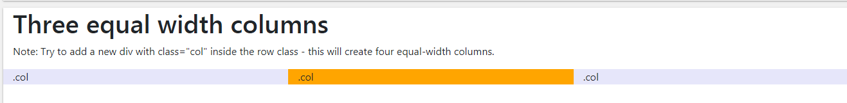

<div class="container">

<h1>Display Headings</h1>

<p>Display headings are used to stand out more than normal headings (larger font-size and lighter font-weight):</p>

<h1 class="display-1">Display 1</h1>

<h1 class="display-2">Display 2</h1>

<h1 class="display-3">Display 3</h1>

<h1 class="display-4">Display 4</h1>

</div>

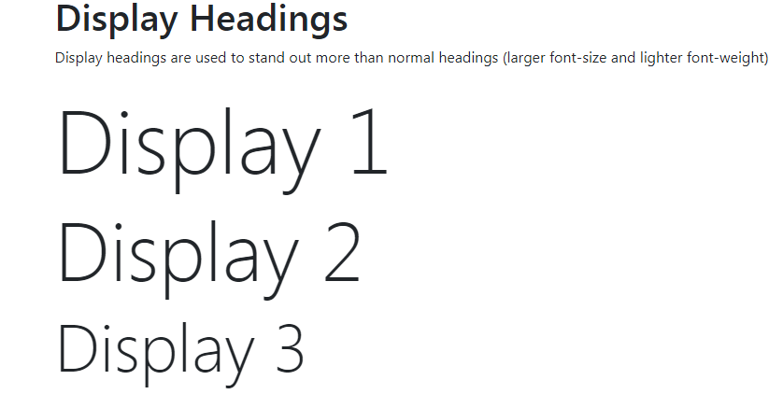

<div class="container">

<h1>Highlight Text</h1>

<p>Use the mark element to <mark>highlight</mark> text.</p>

</div>

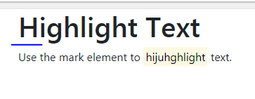

<div class="container">

<h1>Abbreviations</h1>

<p>The abbr element is used to mark up an abbreviation or acronym:</p>

<p>The <abbr title="World Health Organization">WHO</abbr> was founded in 1948.</p>

</div>

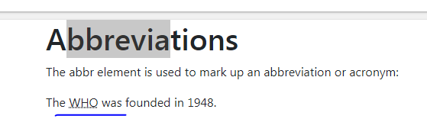

<div class="container">

<h1>Description Lists</h1>

<p>The dl element indicates a description list:</p>

<dl>

<dt>Coffee</dt>

<dd>- black hot drink</dd>

<dt>Milk</dt>

<dd>- white cold drink</dd>

</dl>

</div>

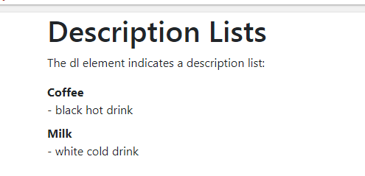

<div class="container">

<h1>Keyboard Inputs</h1>

<p>To indicate input that is typically entered via the keyboard, use the kbd element:</p>

<p>Use <kbd>ctrl + p</kbd> to open the Print dialog box.</p>

</div>

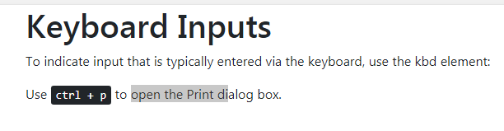

<https://www.w3schools.com/bootstrap4/bootstrap_typography.asp>

<p class="text-primary">This text is important.</p>

<p class="text-success">This text indicates success.</p>

<p class="text-info">This text represents some information.</p>

<p class="text-warning">This text represents a warning.</p>

<p class="text-danger">This text represents danger.</p>

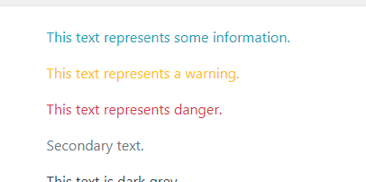

<p class="bg-primary text-white">This text is important.</p>

<p class="bg-success text-white">This text indicates success.</p>

<p class="bg-info text-white">This text represents some information.</p>

<p class="bg-warning text-white">This text represents a warning.</p>

<p class="bg-danger text-white">This text represents danger.</p>

<p class="bg-secondary text-white">Secondary background color.</p>

<p class="bg-dark text-white">Dark grey background color.</p>

<p class="bg-light text-dark">Light grey background color.</p>

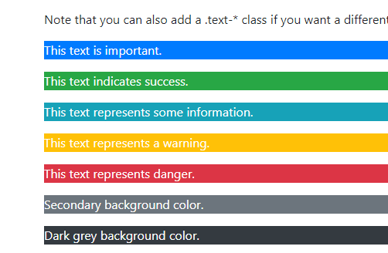

<div class="container">

<h2>Hover Rows</h2>

<p>The .table-hover class enables a hover state (grey background on mouse over) on table rows:</p>

<table class="table table-hover">

<thead>

<tr>

<th>Firstname</th>

<th>Lastname</th>

<th>Email</th>

</tr>

</thead>

<tbody>

<tr>

<td>John</td>

<td>Doe</td>

<td>john@example.com</td>

</tr>

<tr>

<td>Mary</td>

<td>Moe</td>

<td>mary@example.com</td>

</tr>

<tr>

<td>July</td>

<td>Dooley</td>

<td>july@example.com</td>

</tr>

</tbody>

</table>

</div>

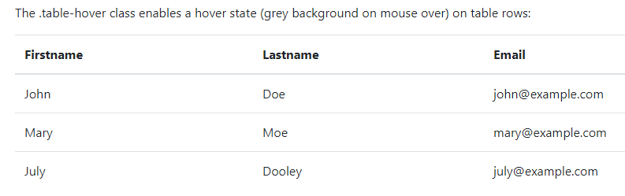

<tbody>

<tr>

<td>Default</td>

<td>Defaultson</td>

<td>def@somemail.com</td>

</tr>

<tr class="table-primary">

<td>Primary</td>

<td>Joe</td>

<td>joe@example.com</td>

</tr>

<tr class="table-success">

<td>Success</td>

<td>Doe</td>

<td>john@example.com</td>

</tr>

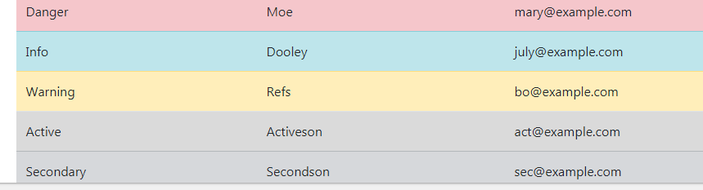

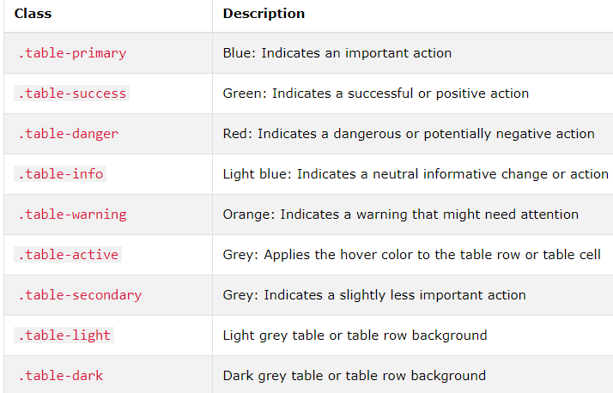

<table class="table">

<thead class="thead-dark">



<table class="table">

<thead class="thead-light">

<tr>

<th>Firstname</th>

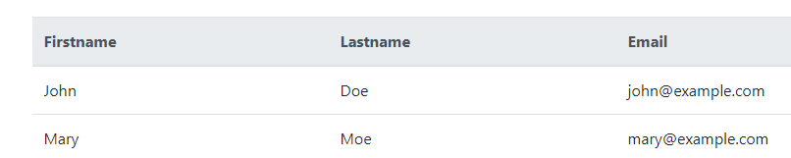

<div class="container">

<h2>Rounded Corners</h2>

<p>The .rounded class adds rounded corners to an image:</p>

<img src="cinqueterre.jpg" class="rounded" alt="Cinque Terre" width="304" height="236">

</div>

<img src="cinqueterre.jpg" class="img-thumbnail" alt="Cinque Terre" width="304" height="236">

<img src="paris.jpg" class="float-left" alt="Paris" width="304" height="236">

<img src="paris.jpg" class="float-right" alt="Paris" width="304" height="236">

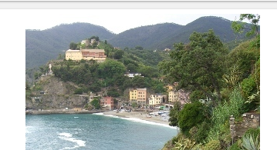

<img src="paris.jpg" class="mx-auto d-block" style="width:50%">



<div class="alert alert-danger">

<strong>Danger!</strong> This alert box could indicate a dangerous or potentially negative action.

</div>

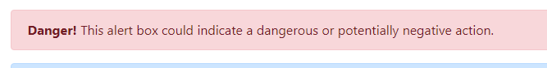

<div class="alert alert-warning alert-dismissible fade show">

<button type="button" class="close" data-dismiss="alert">&times;</button>

<strong>Warning!</strong> This alert box could indicate a warning that might need attention.

</div>

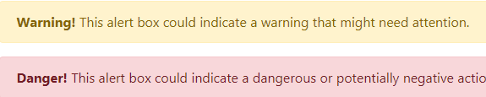

**Button**

<button class="btn btn-primary" disabled>  
  <span class="spinner-border spinner-border-sm"></span>  
  Loading..  
</button>

button type="button" class="btn btn-outline-primary">Primary</button>  
<button type="button" class="btn btn-outline-secondary">Secondary</button>  
<button type="button" class="btn btn-outline-success">Success</button>  
<button type="button" class="btn btn-outline-info">Info</button>  
<button type="button" class="btn btn-outline-warning">Warning</button>  
<button type="button" class="btn btn-outline-danger">Danger</button>  
<button type="button" class="btn btn-outline-dark">Dark</button>  
<button type="button" class="btn btn-outline-light text-dark">Light</button>

<div class="container">

<h2>Button Elements</h2>

<a href="#" class="btn btn-info" role="button">Link Button</a>

<button type="button" class="btn btn-info">Button</button>

<input type="button" class="btn btn-info" value="Input Button">

<input type="submit" class="btn btn-info" value="Submit Button">

</div>

<button type="button" class="btn btn-secondary">Secondary</button>  
<button type="button" class="btn btn-success">Success</button>  
<button type="button" class="btn btn-info">Info</button>

<div class="btn-group">  
  <button type="button" class="btn btn-primary">Apple</button>  
  <button type="button" class="btn btn-primary">Samsung</button>  
  <button type="button" class="btn btn-primary">Sony</button>  
</div>

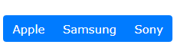

<div class="btn-group-vertical">

<div class="btn-group">  
  <button type="button" class="btn btn-primary">Apple</button>  
  <button type="button" class="btn btn-primary">Samsung</button>  
  <div class="btn-group">  
    <button type="button" class="btn btn-primary dropdown-toggle" data-toggle="dropdown">  
       Sony  
    </button>  
    <div class="dropdown-menu">  
      <a class="dropdown-item" href="#">Tablet</a>  
      <a class="dropdown-item" href="#">Smartphone</a>  
    </div>  
  </div>  
</div>

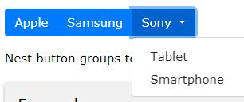

<div class="btn-group-vertical">  
  <button type="button" class="btn btn-primary">Apple</button>  
  <button type="button" class="btn btn-primary">Samsung</button>  
  <div class="btn-group">  
    <button type="button" class="btn btn-primary dropdown-toggle" data-toggle="dropdown">  
       Sony  
    </button>  
    <div class="dropdown-menu">  
      <a class="dropdown-item" href="#">Tablet</a>  
      <a class="dropdown-item" href="#">Smartphone</a>  
    </div>  
  </div>  
</div>

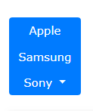

<div class="container">

<h2>Pill Badges</h2>

<span class="badge badge-pill badge-primary">Primary</span>

<span class="badge badge-pill badge-secondary">Secondary</span>

<span class="badge badge-pill badge-success">Success</span>

<span class="badge badge-pill badge-danger">Danger</span>

<span class="badge badge-pill badge-warning">Warning</span>

<span class="badge badge-pill badge-info">Info</span>

<span class="badge badge-pill badge-light">Light</span>

<span class="badge badge-pill badge-dark">Dark</span>

</div>

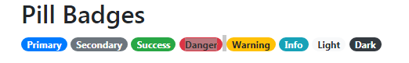

Progress Bar Labels

Add text inside the progress bar to show the visible percentage:

70%

Example

<div class="progress">  
  <div class="progress-bar" style="width:70%">70%</div>  
</div>

<!-- Grey -->  
<div class="progress">  
  <div class="progress-bar bg-secondary" style="width:70%"></div>  
</div>  
  
<!-- Light Grey -->  
<div class="progress border">  
  <div class="progress-bar bg-light" style="width:80%"></div>  
</div>  
  
<!-- Dark Grey -->  
<div class="progress">  
  <div class="progress-bar bg-dark" style="width:90%"></div>  
</div>

Striped Progress Bars

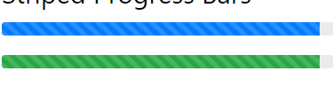

Use the .progress-bar-striped class to add stripes to the progress bars:

<div class="progress">  
  <div class="progress-bar progress-bar-striped" style="width:40%"></div>  
</div>

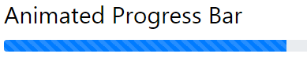

Add the .progress-bar-animated class to animate the progress bar:

<div class="progress-bar progress-bar-striped progress-bar-animated" style="width: 40%"></div>

[Try it Yourself »](https://www.w3schools.com/bootstrap4/tryit.asp?filename=trybs_progressbar5&stacked=h)

Multiple Progress Bars

Progress bars can also be stacked:



<div class="progress">  
  <div class="progress-bar bg-success" style="width:40%">  
    Free Space  
  </div>  
  <div class="progress-bar bg-warning" style="width:10%">  
    Warning  
  </div>  
  <div class="progress-bar bg-danger" style="width:20%">  
    Danger  
  </div>  
</div>

Growing Spinners

Use the .spinner-grow class if you want the spinner/loader to grow instead of "spin":



<div class="spinner-grow text-muted"></div>  
<div class="spinner-grow text-primary"></div>  
<div class="spinner-grow text-success"></div>  
<div class="spinner-grow text-info"></div>  
<div class="spinner-grow text-warning"></div>  
<div class="spinner-grow text-danger"></div>

## Basic Pagination

If you have a web site with lots of pages, you may wish to add some sort of pagination to each page.

To create a basic pagination, add the .pagination class to an <ul> element. Then add the .page-item to each <li> element and a .page-link class to each link inside <li>:



<ul class="pagination">  
  <li class="page-item"><a class="page-link" href="#">Previous</a></li>  
  <li class="page-item"><a class="page-link" href="#">1</a></li>  
  <li class="page-item"><a class="page-link" href="#">2</a></li>  
  <li class="page-item"><a class="page-link" href="#">3</a></li>  
  <li class="page-item"><a class="page-link" href="#">Next</a></li>  
</ul>

## Active State

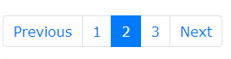

The .active class is used to "hightlight" the current page:

<ul class="pagination">  
  <li class="page-item"><a class="page-link" href="#">Previous</a></li>  
  <li class="page-item"><a class="page-link" href="#">1</a></li>  
  <li class="page-item active"><a class="page-link" href="#">2</a></li>  
  <li class="page-item"><a class="page-link" href="#">3</a></li>  
  <li class="page-item"><a class="page-link" href="#">Next</a></li>  
</ul>

## Disabled State

The .disabled class is used for links that appear un-clickable:

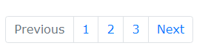

<ul class="pagination">  
  <li class="page-item disabled"><a class="page-link" href="#">Previous</a></li>  
  <li class="page-item"><a class="page-link" href="#">1</a></li>  
  <li class="page-item"><a class="page-link" href="#">2</a></li>  
  <li class="page-item"><a class="page-link" href="#">3</a></li>  
  <li class="page-item"><a class="page-link" href="#">Next</a></li>  
</ul>

## Breadcrumbs

Another form for pagination, is breadcrumbs:



The .breadcrumb and .breadcrumb-item classes indicates the current page's location within a navigational hierarchy:

<ul class="breadcrumb">  
  <li class="breadcrumb-item"><a href="#">Photos</a></li>  
  <li class="breadcrumb-item"><a href="#">Summer 2017</a></li>  
  <li class="breadcrumb-item"><a href="#">Italy</a></li>  
  <li class="breadcrumb-item active">Rome</li>  
</ul>

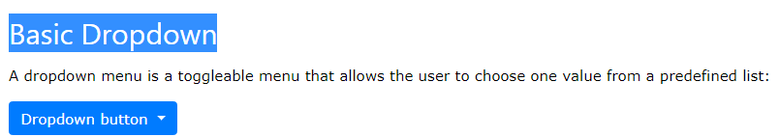

<div class="dropdown">  
  <button type="button" class="btn btn-primary dropdown-toggle" data-toggle="dropdown">  
    Dropdown button  
  </button>  
  <div class="dropdown-menu">  
    <a class="dropdown-item" href="#">Link 1</a>  
    <a class="dropdown-item" href="#">Link 2</a>  
    <a class="dropdown-item" href="#">Link 3</a>  
  </div>  
</div>

## Bootstrap 4 Input Groups

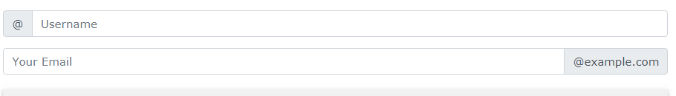

<form>  
  <div class="input-group mb-3">  
    <div class="input-group-prepend">  
      <span class="input-group-text">@</span>  
    </div>  
    <input type="text" class="form-control" placeholder="Username">  
  </div>  
  
  <div class="input-group mb-3">  
    <input type="text" class="form-control" placeholder="Your Email">  
    <div class="input-group-append">  
      <span class="input-group-text">@example.com</span>  
    </div>  
  </div>  
</form>

## Bootstrap 4 Carousel

The Carousel is a slideshow for cycling through elements.



<div id="demo" class="carousel slide" data-ride="carousel">  
  
  <!-- Indicators -->  
  <ul class="carousel-indicators">  
    <li data-target="#demo" data-slide-to="0" class="active"></li>  
    <li data-target="#demo" data-slide-to="1"></li>  
    <li data-target="#demo" data-slide-to="2"></li>  
  </ul>  
  
  <!-- The slideshow -->  
  <div class="carousel-inner">  
    <div class="carousel-item active">  
      <img src="la.jpg" alt="Los Angeles">  
    </div>  
    <div class="carousel-item">  
      <img src="chicago.jpg" alt="Chicago">  
    </div>  
    <div class="carousel-item">  
      <img src="ny.jpg" alt="New York">  
    </div>  
  </div>  
  
  <!-- Left and right controls -->  
  <a class="carousel-control-prev" href="#demo" data-slide="prev">  
    <span class="carousel-control-prev-icon"></span>  
  </a>  
  <a class="carousel-control-next" href="#demo" data-slide="next">  
    <span class="carousel-control-next-icon"></span>  
  </a>  
  
</div>

# Bootstrap 4 Modal

<div class="container">

<h2>Modal Example</h2>

<!-- Button to Open the Modal -->

<button type="button" class="btn btn-primary" data-toggle="modal" data-target="#myModal">

Open modal

</button>

<!-- The Modal -->

<div class="modal" id="myModal">

<div class="modal-dialog">

<div class="modal-content">

<!-- Modal Header -->

<div class="modal-header">

<h4 class="modal-title">Modal Heading</h4>

<button type="button" class="close" data-dismiss="modal">&times;</button>

</div>

<!-- Modal body -->

<div class="modal-body">

Modal body..

</div>

<!-- Modal footer -->

<div class="modal-footer">

<button type="button" class="btn btn-danger" data-dismiss="modal">Close</button>

</div>

</div>

</div>

</div>

</div>

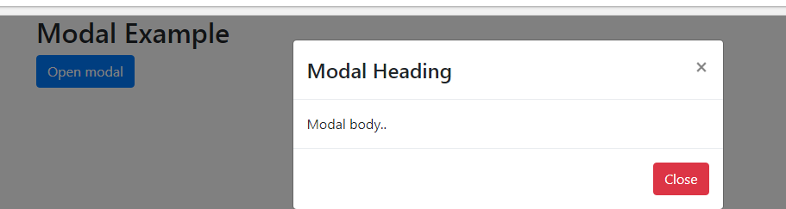

# Bootstrap 4 Scrollspy

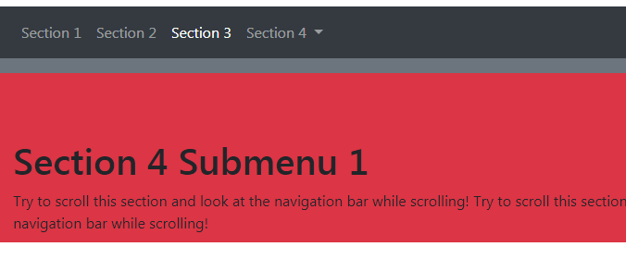

<style>

body {

position: relative;

}

</style>

</head>

<body data-spy="scroll" data-target=".navbar" data-offset="50">

<nav class="navbar navbar-expand-sm bg-dark navbar-dark fixed-top">

<ul class="navbar-nav">

<li class="nav-item">

<a class="nav-link" href="#section1">Section 1</a>

</li>

<li class="nav-item">

<a class="nav-link" href="#section2">Section 2</a>

</li>

<li class="nav-item">

<a class="nav-link" href="#section3">Section 3</a>

</li>

<li class="nav-item dropdown">

<a class="nav-link dropdown-toggle" href="#" id="navbardrop" data-toggle="dropdown">

Section 4

</a>

<div class="dropdown-menu">

<a class="dropdown-item" href="#section41">Link 1</a>

<a class="dropdown-item" href="#section42">Link 2</a>

</div>

</li>

</ul>

</nav>

<div id="section1" class="container-fluid bg-success" style="padding-top:70px;padding-bottom:70px">

<h1>Section 1</h1>

<p>Try to scroll this section and look at the navigation bar while scrolling! Try to scroll this section and look at the navigation bar while scrolling!</p>

<p>Try to scroll this section and look at the navigation bar while scrolling! Try to scroll this section and look at the navigation bar while scrolling!</p>

</div>

<div id="section2" class="container-fluid bg-warning" style="padding-top:70px;padding-bottom:70px">

<h1>Section 2</h1>

<p>Try to scroll this section and look at the navigation bar while scrolling! Try to scroll this section and look at the navigation bar while scrolling!</p>

<p>Try to scroll this section and look at the navigation bar while scrolling! Try to scroll this section and look at the navigation bar while scrolling!</p>

</div>

<div id="section3" class="container-fluid bg-secondary" style="padding-top:70px;padding-bottom:70px">

<h1>Section 3</h1>

<p>Try to scroll this section and look at the navigation bar while scrolling! Try to scroll this section and look at the navigation bar while scrolling!</p>

<p>Try to scroll this section and look at the navigation bar while scrolling! Try to scroll this section and look at the navigation bar while scrolling!</p>

</div>

<div id="section41" class="container-fluid bg-danger" style="padding-top:70px;padding-bottom:70px">

<h1>Section 4 Submenu 1</h1>

<p>Try to scroll this section and look at the navigation bar while scrolling! Try to scroll this section and look at the navigation bar while scrolling!</p>

<p>Try to scroll this section and look at the navigation bar while scrolling! Try to scroll this section and look at the navigation bar while scrolling!</p>

</div>

<div id="section42" class="container-fluid bg-info" style="padding-top:70px;padding-bottom:70px">

<h1>Section 4 Submenu 2</h1>

<p>Try to scroll this section and look at the navigation bar while scrolling! Try to scroll this section and look at the navigation bar while scrolling!</p>

<p>Try to scroll this section and look at the navigation bar while scrolling! Try to scroll this section and look at the navigation bar while scrolling!</p>

</div>

<https://www.w3schools.com/bootstrap4/bootstrap_scrollspy.asp>

## Filterable Table

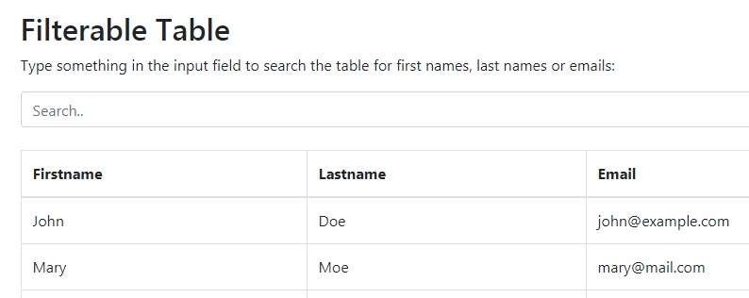

<div class="container mt-3">

<h2>Filterable Table</h2>

<p>Type something in the input field to search the table for first names, last names or emails:</p>

<input class="form-control" id="myInput" type="text" placeholder="Search..">

<br>

<table class="table table-bordered">

<thead>

<tr>

<th>Firstname</th>

<th>Lastname</th>

<th>Email</th>

</tr>

</thead>

<tbody id="myTable">

<tr>

<td>John</td>

<td>Doe</td>

<td>john@example.com</td>

</tr>

<tr>

<td>Mary</td>

<td>Moe</td>

<td>mary@mail.com</td>

</tr>

<tr>

<td>July</td>

<td>Dooley</td>

<td>july@greatstuff.com</td>

</tr>

<tr>

<td>Anja</td>

<td>Ravendale</td>

<td>a_r@test.com</td>

</tr>

</tbody>

</table>

<p>Note that we start the search in tbody, to prevent filtering the table headers.</p>

</div>

<script>

$(document).ready(function(){

$("#myInput").on("keyup", function() {

var value = $(this).val().toLowerCase();

$("#myTable tr").filter(function() {

$(this).toggle($(this).text().toLowerCase().indexOf(value) > -1)

});

});

});

</script>

## Filter Anything

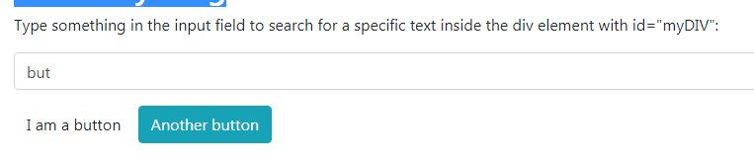

<div class="container mt-3">

<h2>Filter Anything</h2>

<p>Type something in the input field to search for a specific text inside the div element with id="myDIV":</p>

<input class="form-control" id="myInput" type="text" placeholder="Search..">

<div id="myDIV" class="mt-3">

<p>I am a paragraph.</p>

<div>I am a div element inside div.</div>

<button class="btn">I am a button</button>

<button class="btn btn-info">Another button</button>

<p>Another paragraph.</p>

</div>

</div>

<script>

$(document).ready(function(){

$("#myInput").on("keyup", function() {

var value = $(this).val().toLowerCase();

$("#myDIV *").filter(function() {

$(this).toggle($(this).text().toLowerCase().indexOf(value) > -1)

});

});

});

</script>

**Search content in a table**

<input class="form-control" id="**myInput**" type="text" placeholder="Search..">

<script>

$(document).ready(function(){

$("#**myInput**").on("keyup", function() {

var value = $(this).val().toLowerCase();

$("**#myTable tr**").filter(function() {

$(this).toggle($(this).text().toLowerCase().indexOf(value) > -1)

});

});

});

</script>

1. Search data stored to ‘value’ variable and search it in “tr” tags

Here toggle and filter are methods.

Search in the table : $("**#myTable tr**").filter(function()

Search in the page : $("#myDIV *").filter(function()

Search in the list : $("#myList li").filter(function()

**Chart color change**

var options = {

title: 'My Daily Activities','width':550, 'height':400,

slices: {0: {color: '#A9A9A9'}, 1:{color: '#00FF08'}, 2:{color: 'blue'}}

};

(Or)

**var** options = {

width: 400,

height: 240,

title: 'Toppings I Like On My Pizza',

colors: ['#e0440e', '#e6693e', '#ec8f6e']

};